Design Phase Specification: Interactive Polyline Editor

Course: CS 555 Human Computer Interaction
Phase: Design & Behavioral Modeling
Name : Maha Khan
SeatNo:B23110006061

1. Visual Layout of the PolyLine Editor
The PolyLine Editor is designed to be simple, clean, and easy for anyone to use. The main goal is to give the user a big open space to draw polylines while keeping all important information clearly visible. We focused on two key ideas: Visibility (everything the user needs can be seen easily) and Minimalism (we only show what is necessary and remove anything extra).
Layout Description
The screen is divided into three clear and simple zones:
- Main Design Canvas (Center)
  - This is the largest part of the screen, placed right in the middle.
  - It is a big, empty, white workspace.
  - All polylines (connected straight lines that form shapes like houses or objects) are drawn here.
  - The user simply clicks the mouse to add new points and draw lines.
  - Why this is important: The large open space gives the user complete freedom to create their drawing without buttons or text getting in the way.
- Command Sidebar (Left Side)
  - A narrow panel on the left side of the screen.
  - It shows the main actions grouped together: • Begin (start a new polyline) • Move (drag a point to a new location) • Delete (remove a point) • Refresh (clear and redraw everything) .Close (
  - These actions are kept close together because they are related.
  - Why this is important: This follows the HCI principle of Proximity — keeping related functions near each other so the user can find them quickly without searching.
- Status and Legend Bar (Top)
  - A thin bar at the very top of the window.
  - It always displays: • The program title: PolyLine Editor • Real-time instructions (for example: “Press B to begin a new polyline” or “Click near a point to move it”) • A clear reminder of keyboard shortcuts: B = Begin, M = Move, D = Delete, R = Refresh, Q = Quit
  - Why this is important: It reduces the user’s cognitive load (the effort needed to remember things). The user does not have to memorize the keys — they are always visible on the screen.
Additional Feedback Area (Bottom Status Bar)
- At the bottom of the screen there is a small bar that shows instant messages after every action, such as: “New point added”, “Point moved successfully”, “Point deleted”, or “Screen refreshed”.
- This gives the user immediate feedback so they always know what happened.
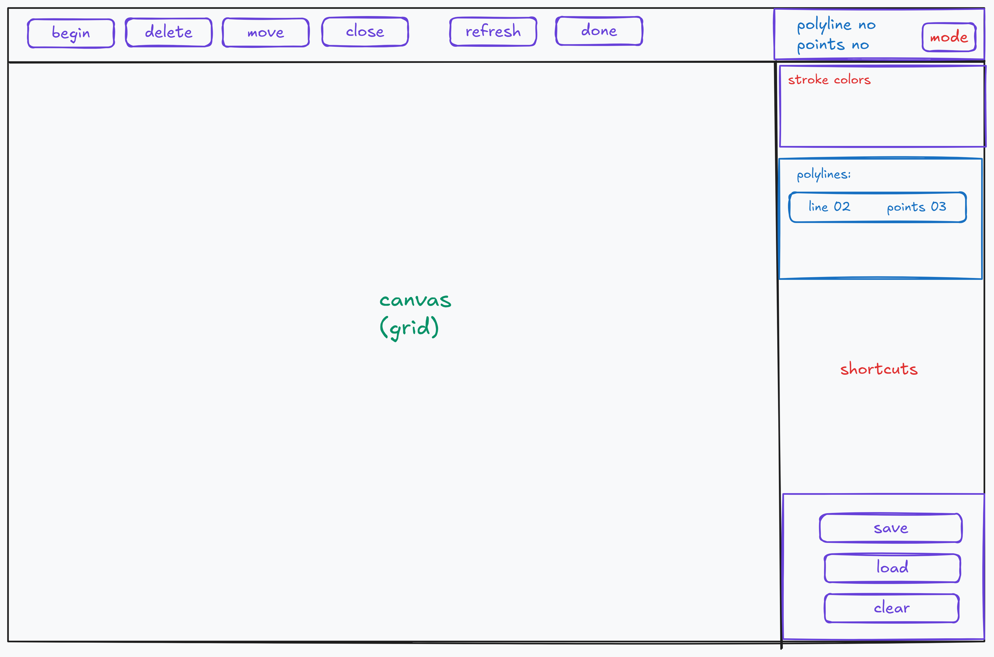
2. State Transition Network (STN) of the PolyLine Editor
The PolyLine Editor has a few simple states. The program starts in the “Idle” state and moves to other states when the user presses keyboard keys (B, M, D, R) or clicks the mouse. The STN shows these changes with boxes (states) and arrows (transitions).
Main States of the PolyLine Editor
- Idle / Ready State
  - This is the starting and normal state when the program opens.
  - The user can press any key to begin an action.
  - No drawing is happening yet.
- Creating Polyline State (Begin Mode)
  - The program enters this state when the user presses ‘B’.
  - Every mouse click adds a new point and draws a line to the previous point.
  - The user can keep adding points to build a shape (like a house).
- Move Mode
  - The program enters this state when the user presses ‘M’.
  - The user clicks near a point to select it, then clicks again at a new location to move the point.
  - Connected lines are automatically redrawn.
- Delete Mode
  - The program enters this state when the user presses ‘D’.
  - The user clicks near a point, the point is removed, and the two neighboring points are joined with a new line.
Other Important Functions and Transitions
In addition to the four main states, the editor also supports these helpful functions:
Done (Press 'F'):
Finalizes the current drawing. It tells the system you are finished placing points for the current shape. This stops the "rubber-band" line from following your cursor and returns the system to an Idle state so you don't accidentally add more points.
Refresh (Press 'R'):
Cleans and redraws the entire canvas. It wipes the screen and loops through all the stored data to redraw everything from scratch. This is used to fix any visual glitches and ensure the "Hover" highlights are showing up in the right places for the current mode.
Right Click (Insert):
Adds a new point into the middle of an existing line. Instead of drawing at the end of the shape, it splits an existing segment in two and places a new vertex exactly where you clicked.
- Undo or Ctrl+Z :
Reverts the very last action you took. If you placed a point by mistake, this "pops" that specific point out of the data array and restores the shape to its previous state. A "Toast: undone" message confirms the change.
- Close :
Pressing 'C' toggles the Close state. This action completes the shape by drawing a final segment from the current point back to the start and applies an interior fill color to indicate the polygon is now a closed entity.
Del or Backspace:
The Delete or Backspace key functions as a global Cancel command that immediately transitions the system from any active operational mode back to its default IDLE state. This action performs a complete visual reset by clearing all temporary UI elements, such as "rubber-band" lines and "ghost" vertices, from the canvas. Additionally, it clears any active selections or cursor changes, effectively dropping the current tool without modifying any of the underlying saved data.
These extra functions make the editor more flexible and help the user fix mistakes easily.
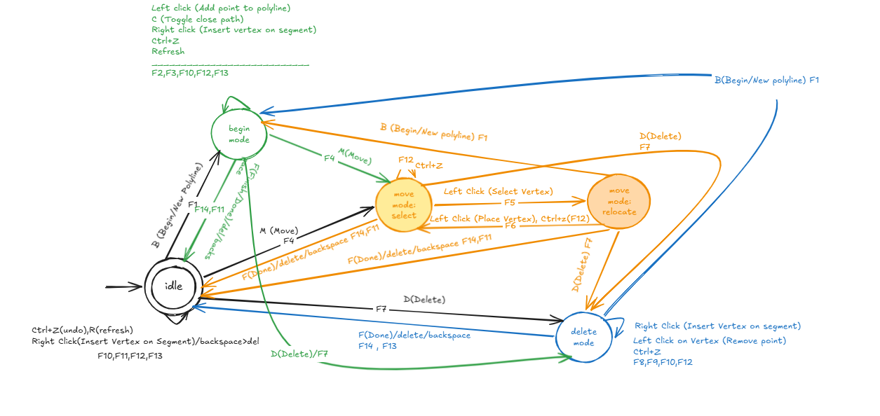
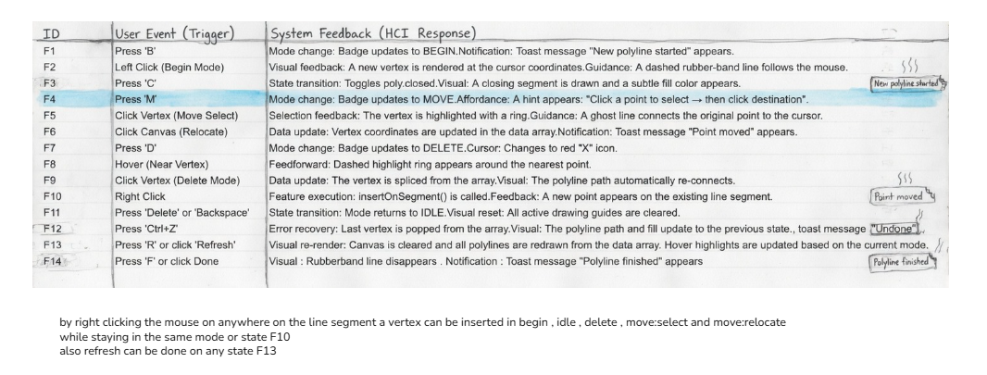
Figure 2: State Transition Network (STN) of the Polyline Editor
7.5 Alignment of Design Principles with the Polyline Editor
The Polyline Editor was evaluated against “Shneiderman’s Eight Golden Rules”, “Norman’s Seven Principles of User-Centered Design”, “Miller’s Law”, and “Fitts’s Law”. This section demonstrates how the interface successfully implements these classic HCI principles through its layout, interaction design, visual feedback, and feature set (including the FR-09 Close Path functionality).
Annotated screenshots are used to illustrate each principle in context. The editor was prepared with sample polylines (one open polyline and one closed polygon) to clearly show active states, modes, and visual feedback.

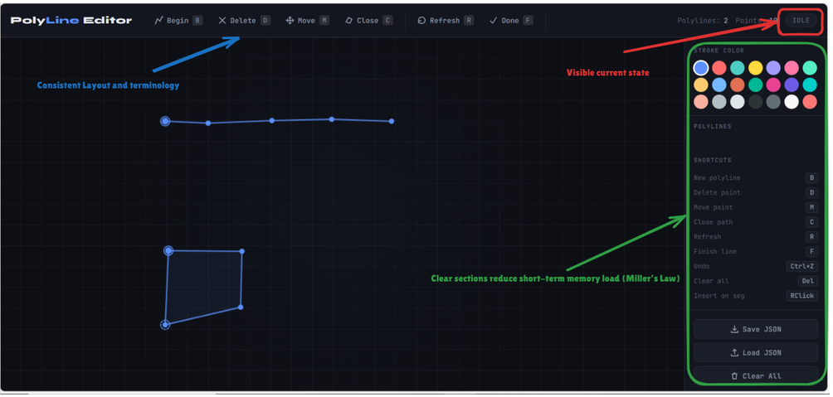
Figure 1. Overall interface layout showing consistent design and support for reducing short-term memory load
This screenshot displays the complete Polyline Editor interface. The consistent dark theme, grouped toolbar, prominent canvas, and well-organized sidebar follow Shneiderman’s Rule 1 (Consistency) and Rule 8 (Reduce short-term memory load). The limited number of visible elements and clear sectioning also respects Miller’s Law (keeping cognitive load under 7±2 items). Norman’s Principle 1 is supported through visible knowledge in the world (icons, labels, and status badge).

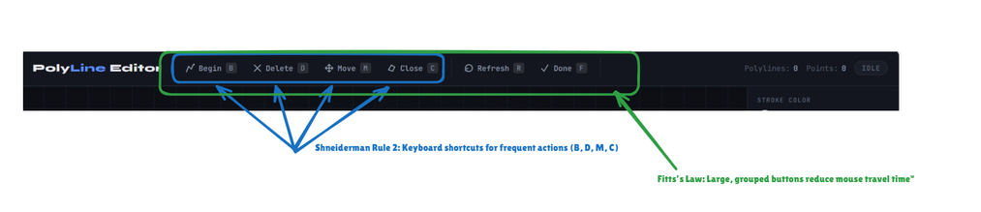
Figure 2. Top toolbar demonstrating keyboard shortcuts and large button design.
The toolbar provides direct access to all core functions with visible keyboard shortcuts (B, D, M, C, F, R). This strongly supports Shneiderman’s Rule 2 (Enable frequent users to use shortcuts). The large, grouped buttons with adequate spacing also apply Fitts’s Law by reducing target acquisition time. The inclusion of the “Close” button (FR-09) with its dedicated shortcut makes advanced functionality easily accessible.

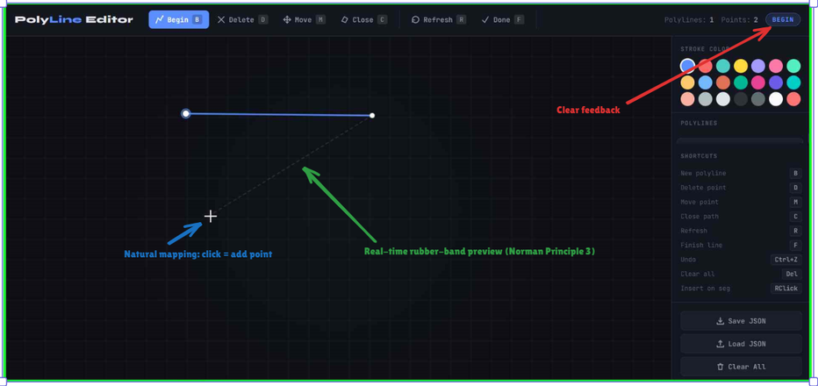
Figure 3. Begin mode showing real-time visual feedback during drawing.
While in Begin mode, a dashed rubber-band line provides immediate preview of the next segment. This excellent implementation of Norman’s Principle 3 (Make things visible) and Principle 4 (Get the mappings right) bridges the gulf of execution by clearly showing the effect of user actions. The mode badge updating to “BEGIN” further provides Shneiderman’s Rule 3 (Informative feedback).

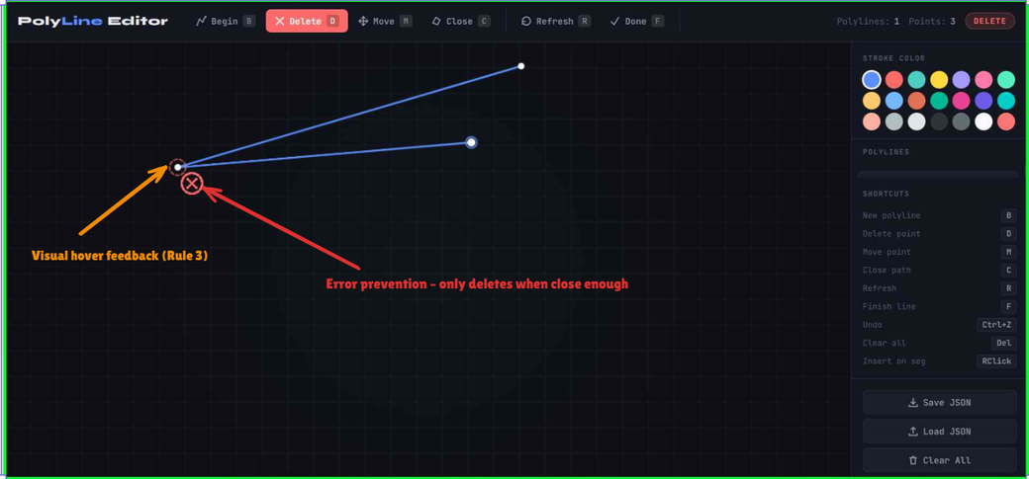
Figure 4. Delete mode demonstrating visual feedback and error prevention.
In Delete mode, hovering near a vertex displays a clear red highlight circle. This gives strong informative feedback (Shneiderman Rule 3) and helps prevent accidental deletions (Rule 5 – Error prevention). The custom cursor and snap radius further support Norman’s Principle 6 (Design for error) by making mistakes less likely.

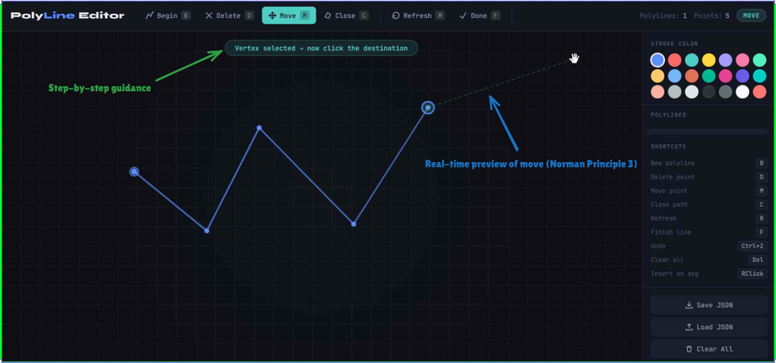
Figure 5. Move mode showing step-by-step guidance and real-time preview.
After selecting a vertex in Move mode, a teal highlight and ghost line appear, showing the intended new position. The on-screen hint box guides the user through the two-step process. This demonstrates Norman’s Principle 3 (Visibility) and Shneiderman’s Rule 3 (Informative feedback) very effectively.

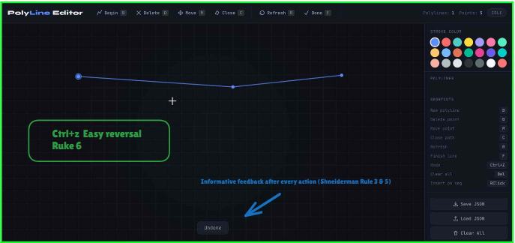
Figure 6. Toast messages and undo functionality providing feedback and error recovery

very significant action triggers a toast message, and the application maintains a 60-step undo history accessible via Ctrl+Z. This provides strong support for Shneiderman’s Rule 6 (Easy reversal of actions) and Rule 5 (Simple error handling), as well as Norman’s Principle 6 (Design for error).

Screenshot 7,8 requires the updated polyline editor with polylist
Miller’s Law (7 ± 2)
The editor keeps things simple. There are only 4 main modes, the toolbar is grouped into
small sections, and the sidebar has clear parts (Colors → Polylines → Shortcuts). This helps users avoid feeling overwhelmed, which follows Miller’s Law.
Fitts’s Law
The toolbar buttons are large and easy to reach. More importantly, every mode has a keyboard shortcut, so users don’t always have to move the mouse to the top bar. This makes switching modes faster, especially for people who like using the keyboard.

Limitations: Rules That Are Weakly Applied
Even though the Polyline Editor is good overall, some principles are not fully applied. Here’s an honest look at the weaker areas:

Shneiderman’s Rule 7 (Internal Locus of Control): The editor uses strict modes (Begin, Delete, Move). You must switch modes before doing different actions. This means the system controls the workflow more than the user. It would feel better if users had more freedom (for example, by holding a key to temporarily change tools).

Norman’s Principle 5 (Exploit the Power of Constraints): There are very few smart constraints. The editor only checks basic things like needing at least 3 points to close a path. It does not prevent messy shapes, self-intersecting lines, or help with alignment.

Norman’s Principle 7 (Standardization): The shortcuts (B, D, M, C, etc.) are custom. They do not match the standard shortcuts used in popular tools like Figma or Illustrator. Users who know other drawing programs may have to re-learn the keys.

Fitts’s Law (Small Limitation): While keyboard shortcuts help a lot, mouse users still need to move the mouse to the top toolbar every time they want to change modes. A floating toolbar or quick modifier keys would make it even better.

